

**SCHOOL ADMINISTRATION SYSTEM**

**CONTENTS**

1. INTRODUCTION
2. WORKING ENVIRONMENT
3. SYSTEM ANALYSIS

* EXISTING SYSTEMS
* LIMITATIONS OF EXISTING SYSTEM
* PROPOSED SYSTEM
* ADVANTAGES OF PROPOSED SYSTEM

1. SYSTEM DESIGN

* SYSTEM DEFINITION
* FILE DEFINITION
* CLASS DEFINITION

1. OUTPUT SCREEN
2. SOURCE CODE
3. CONCLUSION
4. BIBILIOGRAPHY

**INTRODUCTION**

The project titled “SCHOOL ADMINISTRATION SYSTEM” intends to develop a tool that could definitely improve the huge amount of data processing. This project has been developed using C++ which is an object-oriented program.

The project was developed with the sum of solving the problem of maintaining the number of files and easy data retrieval according to the need. The main function performed by this tool include entry function, edit function, search function and display function and also to enter then details of the students. The tool has a friendly inter face and environment that makes adding, deleting and modifying of customer details easy. Its aim is faster data access. It is also user friendly and systematic.

**WORKING ENVIRONMENT**

SOFTWARE: Operating system: Windows 7

Language: C++

HARDWARE: Processor: Intel Pentium

Clock speed: 2.8 GHz

RAM: 2GB

Hard disk: 160GB

Keyboard: 101/102 standard

Mouse: PS/2 compatible series

Display: SVGA color

**SYSTEM ANALYSIS**

System analysis is the process of gathering and interpreting data facts diagnosing the problem to the system. In the development of software, structural analysis is required.

During this analysis, information is collected in the form of answers to the questions for collecting information from existing document. The purpose is to identify the new system and establish what new system to accomplish.

System analysis is an important activity that takes place when a new system is been built. It is the central intact of the systems and it includes gathering and developing a plan to a new system. System analysis should be creative and imaginative in providing new solution to meet their requirements.

**EXISTING SYSTEM:**

The details of students are manually entered into the booklet

Limitations of current system:

* Consumes much space and time.
* Accuracy is less.
* Involves implicated manual labor.
* Difficult to make changes.

**PROPOSED SYSTEM**

In the proposed system we are developing new software carefully. Studying the existing system, customer details can be added, modified, deleted and viewed can be done easily since the program is menu driven.

Advantages of then current system:

* Can add student details easily
* Can view admission no, name, age, sex, phone number, place.
* Can add or delete student record.
* Easily modifiable.
* User friendly.
* Stores details of students.

**SYSTEM DESIGN**

SYSTEM DEFITION:

A system can be defined as a network of interrelated procedure that are joined together to perform an activity or to accomplish a specific objective. It is in effect all ingredients that make up the whole.

CLASS DEFINITION:

Class is used to bind data members and member functions together. It provides data security. It is a user defined data type. Class used in program is ‘OSWAL’ and the object is ‘b’.

DATA MEMBERS:

* admno : stores admission no
* name: stores name of the student
* age : stores age of the student
* sex: stores phone no of the student
* phone : stores phone no of the student

MEMBER FUNCTIONS:

* Void enter(): to enter student details
* Void display(): to display student details
* int retadmno(): return student admission no
* int last_member():return student admission no of last student
* Void modify_data():modify the existing student details

FILE DEFINITION:

A file is a collection of logically related information. It is also a means to store data, having an appreciably large storage space. This is done so because data base of this programs are too large, that can’t be stored in a large memory

FILES:

File used to store student details are student.dat and temp.dat (for deletion menu).

STREAM OBJECTS:

The stream objects used for ‘read’ and ‘write’ are f, f2 and file.

**OUTPUT SCREENS**

**ADDING**

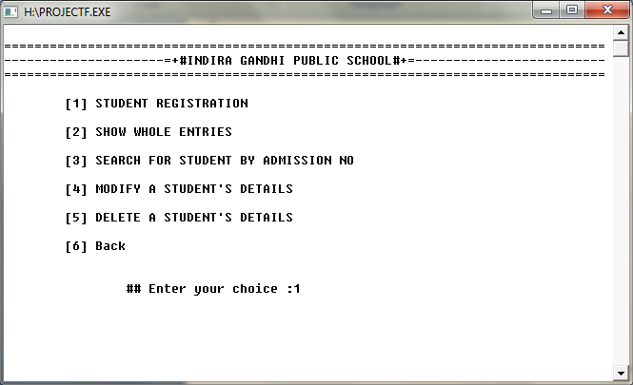

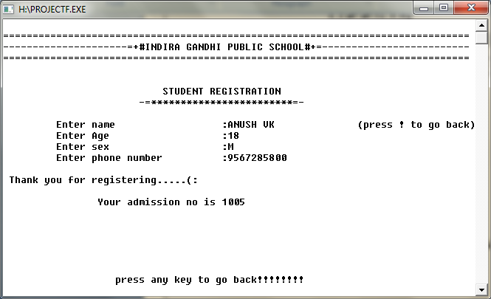

**DISPLAY**

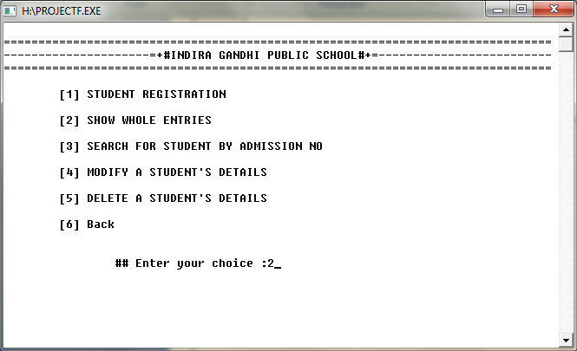

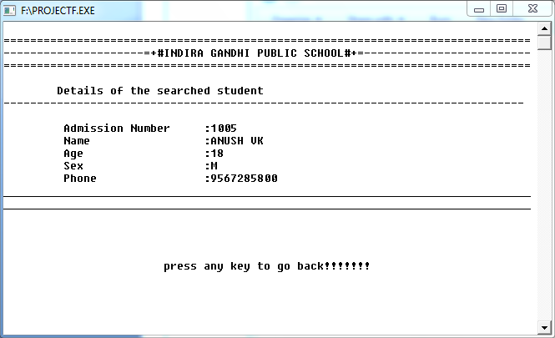

**SEARCHING**

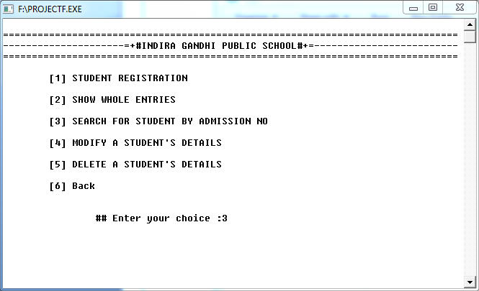

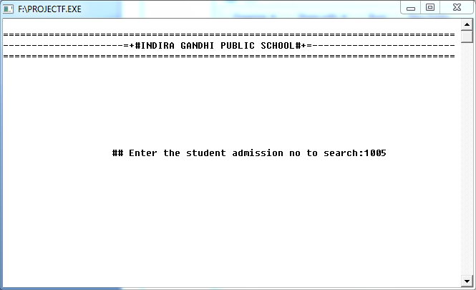

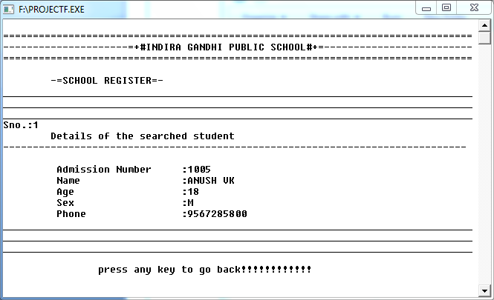

**MODIFYING**

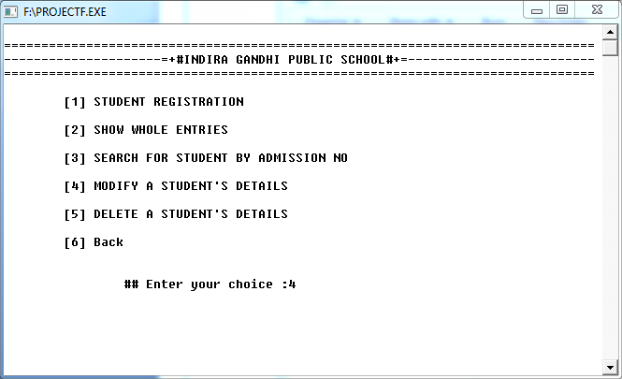

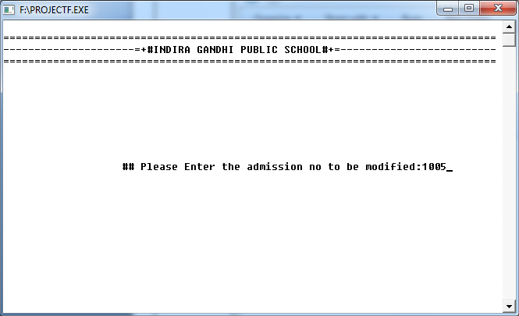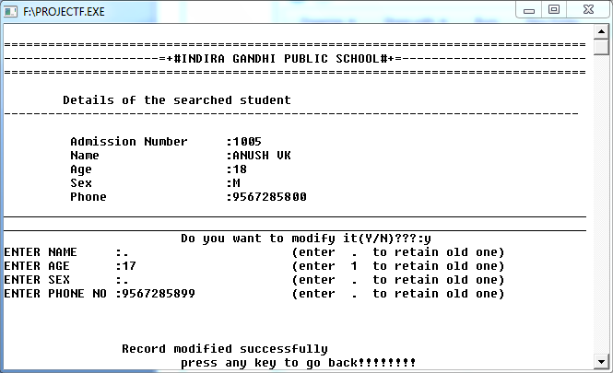

**DELETING**

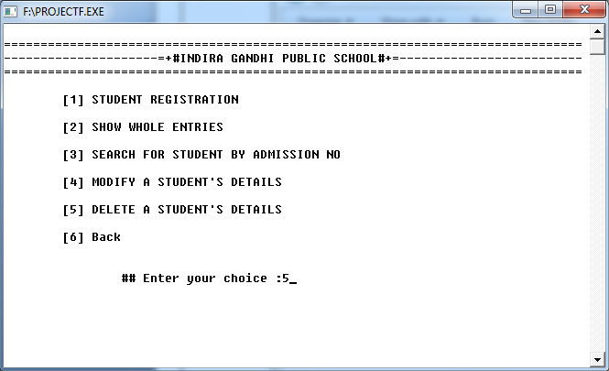

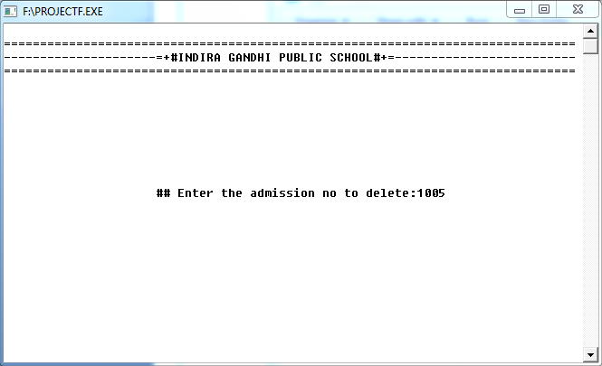

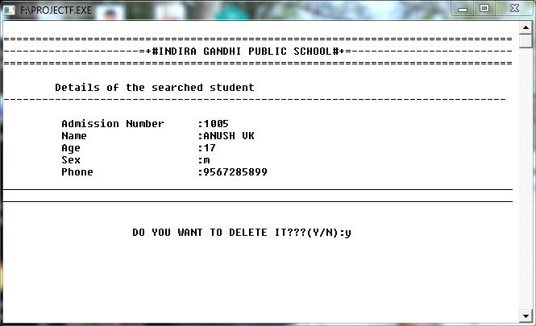

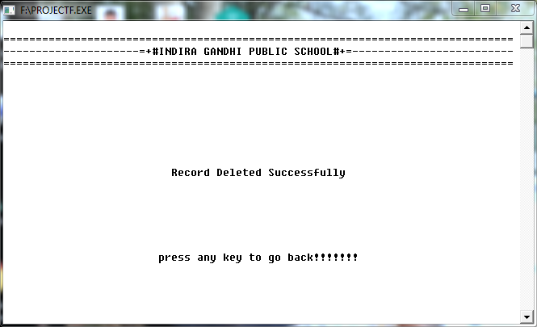

**GOING BACK**

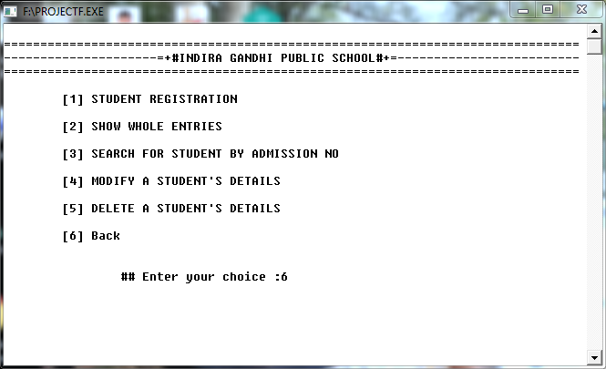

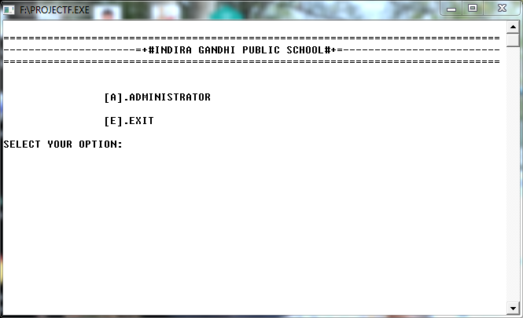

**EXIT**

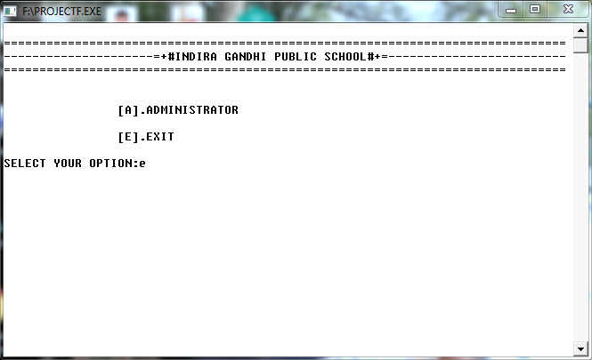

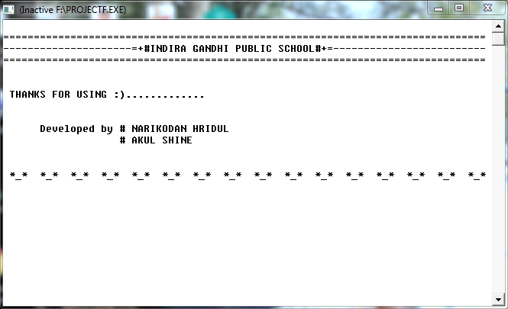

**SOURCE CODE**

#include<iostream>

#include<fstream>

#include<stdio.h>

#include<conio.h>

#include<string.h>

#include<ctype.h>

#include<process.h>

using *namespace* std;

#include "windows.h"

*void* gotoxy(*int* *x*, *int* *y*)

{

    COORD coord;

    coord.X = *x*;

    coord.Y = *y*;

    SetConsoleCursorPosition(GetStdHandle(STD_OUTPUT_HANDLE), coord);

}

*void* add_data();

*void* viewall();

*void* searchadmno();

*void* delete_();

*void* modify();

*void* details();

*void* sc();

*int* disp(*int* *bl*);

*void* screen1();

*void* pass();

*void* adscreen();

*void* userscreen();

*void* user(*int* *ch*);

*void* adm(*int* *ch*);

*void* exi();

*int* count();

*int* main(*int* *argc*, *char* \*\**argv*)

{

    // system("cls");

//  clrscr();

    screen1();

     return 0;

}

*class* student

{

*int* admno;

*char* name[30];

*int* age;

*char* sex[6];

*char* phone[12];

*public:*

*void* enter();

*void* display();

*int* last_member();

*void* modify_data();

*int* retadmno();

 };

 fstream f;

 student a;

*int* student::retadmno()

 {

 return admno;

 }

*int* student::last_member()

 {

*int* count=1000;

  admno=1000;

  fstream file;

  file.open("student.dat",ios::in);

  file.seekg(0,ios::beg);

  while(file.read((*char*\*)this,sizeof(student)))

  {

        count=admno;

  }

  file.close();

  return count;

  }

*void* student::modify_data()

  {

*char* nm[20]=" ",sx[20]=" ",ph[20]=" ";

*int* ag;

  cout<<"ENTER NAME     :                       (enter  .  to retain old one)\n";

  cout<<"ENTER AGE      :                       (enter  1  to retain old one)\n";

  cout<<"ENTER SEX      :                       (enter  .  to retain old one)\n";

  cout<<"ENTER PHONE NO :                       (enter  .  to retain old one)\n";

        gotoxy(17,17);

        gets(nm);

        gotoxy(17,18);

        cin>>ag;

        gotoxy(17,19);

        gets(sx);

        gotoxy(17,20);

        gets(ph);

        if(strcmp(nm,".")!=0)

        strcpy(name,nm);

        if(ag!=1)

        age=ag;

        if(strcmp(sx,".")!=0)

        strcpy(sex,sx);

        if(strcmp(ph,".")!=0)

        strcpy(phone,ph);

        cout<<"\n\n\n\t\tRecord modified successfully";

        gotoxy(25,25);

        cout<<"press any key to go back!!!!!!!!";

        }

*void* student::enter()

        {

            system("cls");

        // clrscr();

        sc();

        cout<<"\n\n                           STUDENT REGISTRATION           \n";

        cout<<"                       -=************************=-            ";

        admno=last_member();

        admno++;

        cout<<"\n\n\t Enter name \t             :                      (press ! to go back)";

        gotoxy(39,10);

        gets(name);

        if(strcmp(name,"!")==0)

        {

        return;

        }

        cout<<"\t Enter Age                   :";

        cin>>age;

        cout<<"\t Enter sex                   :";

        gets(sex);

        cout<<"\t Enter phone number          :";

        gets(phone);

        // cout<<"\n Thank you for registering.....(:";

        cout<<"\n\n\t\tYour admission no is "<<admno;

        }

*void* student::display()

         {

            cout<<"\n";

            cout<<"\tDetails of the searched student\n";

            cout<<"------------------------------------------------------------------------------\n";

            cout<<"\n         Admission Number     :";

            cout<<admno<<"\n";

            cout<<"         Name                 :";

            for(*int* i=0;name[i]!='\0';i++)

                            name[i]=toupper(name[i]);

                            cout<<name<<"\n";

                            cout<<"         Age                  :";

                            cout<<age<<"\n";

                            cout<<"         Sex                  :";

                            cout<<sex<<"\n";

                            cout<<"         Phone                :";

                            cout<<phone<<"\n";

                        cout<<"_______________________________________________________________________________\n";

                        cout<<"_______________________________________________________________________________\n";

}

*void* screen1()

{

    start:

    system("cls");

    // clrscr();

*char* ch;

    sc();

    cout<<"\n\n";

    cout<<"\t\t[A].ADMINISTRATOR\n";

    cout<<"\n";

    cout<<"\t\t[E].EXIT\n\n";

    cout<<"SELECT YOUR OPTION:";

    cin>>ch;

    switch(ch)

    {

        case 'A':

        case 'a':system("cls");

                    // clrscr();

                    pass();

                    adm:

                    adscreen();

                    goto adm;

        case 'E':

        case 'e':exi();

        default:cout<<"So Sorry!!!Unknown Choice";

                    getch();

                  goto start;

    }

}

*void* pass()

{

    sc();

*char* c[20];

*double* x;

*char* user[20];

    loop:

    gotoxy(30,12);

    cout<<"USER NAME:";

    gotoxy(30,13);

    cout<<"PIN      :";

    gotoxy(40,12);

    gets(user);

    cout<<"\n\n";

    gotoxy(40,13);

    for(*int* i=0;i<8;i++)

    {

        c[i]=getch();

        cout<<"*";

    }

    c[0]='\0';

    cout<<"\n";

if(((strcmp(user,"narikul")==0)||(strcmp(user,"NARIKUL")==0))&&(strcmp(c,"password")==0))

    {system("cls");

        // clrscr();

        sc();

        gotoxy(37,13);

        cout<<"WELCOME";

        for(x=0;x<1;x++);

    }

    else if((strcmp(user,"narikul")!=0)&&(strcmp(user,"NARIKUL")!=0))

    {

        system("cls");

        // clrscr();

        sc();

        gotoxy(25,13);

        cout<<"Oops!!! ADMINISTRATION NOT RESPONDING\n\t\t\t (user name is wrong!!!!!)";

        getch();

        screen1();

    }

    else if(strcmp(c,"password")!=0)

    {

        system("cls");

            // clrscr();

        sc();

        gotoxy(25,13);

        cout<<"Oops!!! ADMINISTRATION NOT RESPONDING\n\t\t\t (password is wrong!!!!!)";

        getch();

        screen1();

    }

}

*void* sc()

{

    cout<<"\n===============================================================================\n";

    cout<<"---------------------=+#INDIRA GANDHI PUBLIC SCHOOL#+=-------------------------\n";

    cout<<"===============================================================================\n";

}

*void* adscreen()

{

*char* ch;

    system("cls");

    // clrscr();

    sc();

    cout<<"\n\t[1] STUDENT REGISTRATION      \n\n";

    cout<<"\t[2] SHOW WHOLE ENTRIES      \n\n";

    cout<<"\t[3] SEARCH FOR STUDENT BY ADMISSION NO    \n\n";

    cout<<"\t[4] MODIFY A STUDENT'S DETAILS        \n\n ";

    cout<<"\t[5] DELETE A STUDENT'S DETAILS         \n\n";

    cout<<"\t[6] Back                    \n\n";

    cout<<"\n\t\t## Enter your choice :";

    cin>>ch;

    adm(ch);

    getch();

}

*void* exi()

{

    system("cls");

    // clrscr();

    sc();

    cout<<"\n\n THANKS FOR USING :).............\n";

    cout<<"\n\n      Developed by # NARIKODAN HRIDUL\n";

    cout<<"                   # AKUL SHINE\n";

    cout<<"\n\n *_*  *_*  *_*  *_*  *_*  *_*  *_*  *_*  *_*  *_*  *_*  *_*  *_*  *_*  *_*  *_*";

    exit(0);

}

*void* adm(*int* *ch*)

{

    switch(*ch*)

  {

        case '1':add_data();

                 break;

        case '2':viewall();

                 break;

        case '3':searchadmno();

                 break;

        case '4':modify();

                 break;

        case '5':delete_();

                 break;

        case '6':screen1();

                 break;

        default:cout<<"So Sorry!!!Unknown Choice\n TRY AGAIN....";

  }

}

*void* add_data()

{

    f.open("student.dat",ios::app);

    a.enter();

    f.write((*char*\*)&a,sizeof(student));

    f.close();

    gotoxy(20,24);

    cout<<"press any key to go back!!!!!!!!";

}

*void* viewall()

{

    system("cls");

    // clrscr();

    sc();

    cout<<"\n   -=SCHOOL REGISTER=-           \n";

    cout<<"_______________________________________________________________________________\n";

    cout<<"_______________________________________________________________________________\n";

    cout<<"_______________________________________________________________________________\n";

*int* i=1;

    f.open("student.dat",ios::in|ios::binary);

    while(f.read((*char*\*)&a,sizeof(student)))

    {

        cout<<"Sno.:"<<i;

        a.display();

        i++;

        cout<<"_______________________________________________________________________________\n";

    }

    f.close();

    cout<<"\n\t\tpress any key to go back!!!!!!!!!!!!";

}

*void* searchadmno()

{

*int* n;

  system("cls");

//   clrscr();

  sc();

*int* flag=0;

  gotoxy(20,13);

  cout<<"## Enter the student admission no to search:";

  cin>>n;

  f.open("student.dat",ios::in);

  while(f.read((*char*\*)&a,sizeof(student)))

  {

        if(a.retadmno()==n)

        {

            system("cls");

            // clrscr();

            sc();

            a.display();

            flag=1;

        }

  }

  f.close();

  if(flag==0)

  {

    system("cls");

        // clrscr();

        sc();

        gotoxy(28,13);

        cout<<"Oops!!Record not found!!";

        gotoxy(25,20);

        cout<<"press any key to go back!!!!!!!";

  }

  else

  {

        gotoxy(25,20);

        cout<<"press any key to go back!!!!!!!";

  }

}

*int* count()

{

*int* i=1;

    f.open("student.dat",ios::in|ios::binary);

    while(f.read((*char*\*)&a,sizeof(student)))

    {

        i++;

    }

    f.close();

    return i;

}

*int* disp(*int* *bl*)

{

    system("cls");

//   clrscr();

  sc();

*int* flag=1;

  f.open("student.dat",ios::in);

  while(f.read((*char*\*)&a,sizeof(student)))

  {

        if(a.retadmno()==*bl*)

        {

            a.display();

            flag=0;

        }

  }

  f.close();

  if(flag==1)

  {

    system("cls");

        // clrscr();

        sc();

        gotoxy(28,13);

        cout<<"Oops!!Record not found!!";

        gotoxy(25,20);

        cout<<"press any key to go back!!!!!!!";

  }

  return flag;

}

*void* modify()

{

    system("cls");

    // clrscr();

    sc();

*int* bl,t;

*char* ch;

*long* pos;

    gotoxy(20,13);

    cout<<"## Please Enter the admission no to be modified:";

    cin>>bl;

    t=disp(bl);

    if(t==0)

    {

        f.open("student.dat",ios::in|ios::out);

        cout<<"\t\t\tDo you want to modify it(Y/N)???:";

        cin>>ch;

        if(ch=='y'||ch=='Y')

        {

            while(!f.eof())

            {

                pos=f.tellg();

                f.read((*char*\*)&a,sizeof(student));

                if(a.retadmno()==bl)

                {

                    a.modify_data();

                    f.seekg(pos);

                    f.write((*char*\*)&a,sizeof(student));

                    break;

                }

                    }

        }

        else

        {

            gotoxy(25,25);

            cout<<"press any key to go back!!!!!!!";

        }

        f.close();

    }

}

*void* delete_()

{

*int* no,t;

*char* ch;

 system("cls");

//  clrscr();

 sc();

 gotoxy(22,13);

 cout<<"## Enter the admission no to delete:";

 cin>>no;

 t=disp(no);

 if(t==0)

 {

    gotoxy(21,18);

    cout<<"DO YOU WANT TO DELETE IT ? (Y/N) :";

    cin>>ch;

    if(ch=='y'||ch=='Y')

    {

        f.open("student.dat",ios::in);

        fstream f2;

        f2.open("tem.dat",ios::out);

        f2.seekg(0);

        while(f.read((*char*\*)&a,sizeof(student)))

        {

            if(a.retadmno()!=no)

            {

                f2.write((*char*\*)&a,sizeof(student));

            }

        }

        f2.close();

        f.close();

        remove("student.dat");

        rename("tem.dat","student.dat");

        // clrscr();

        system("cls");

        sc();

        gotoxy(27,13);

        cout<<"Record Deleted Successfully";

        gotoxy(25,20);

        cout<<"press any key to go back!!!!!!!";

    }

else

  {

    gotoxy(25,25);

        cout<<"press any key to go back!!!!!!!";

  }

 }

}

**CONCLUSION**

The new software has turned out to be a success since it over comes almost all the limitations of the existing system. The software is designed to be user friendly & helps to carry out the processes accurately and fast hence it is free from manual errors and is time saving. The software is easily modifiable and can be regularly updated without much expense. It has truly made work in schools easy.

It has a few disadvantages too. The user of software is power consuming and prone to errors if not used by trained persons. Hence any technical experts are advised to use the software.

**BIBLIOGRAPHY**

1. <http://www.google.com/>
2. <http://www.en.wikipedia.org/>
3. Computer science with C++ by Sumita Arora
4. Object Oriented Programming by Robert Lafore
5. [www.bOtskOOL.com](http://www.bOtskOOL.com).